A000 **AM,C-Guatemala-**Lake Amatitlan-Foot or Shoe-shaped Ceramic Vessel-Highland Mayan-Late Classic Period-550-900 CE

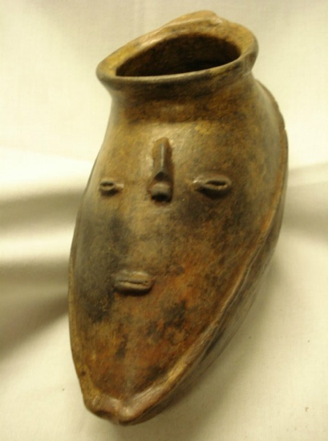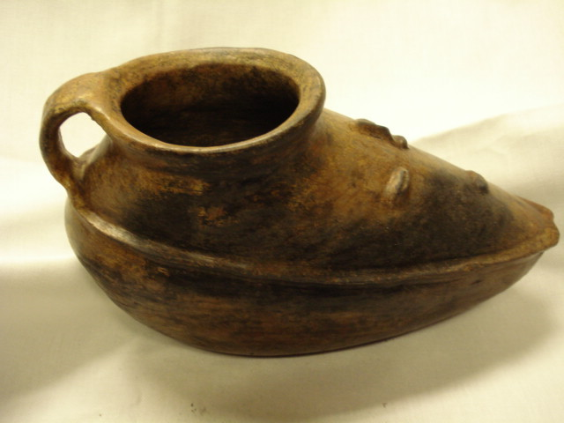

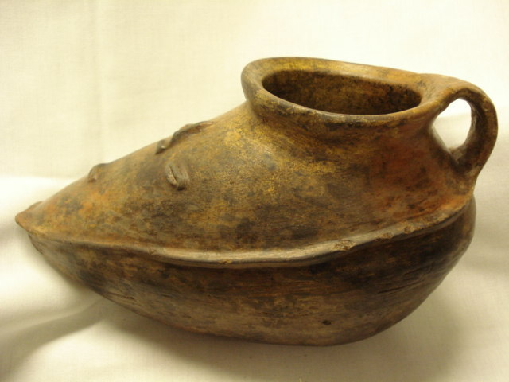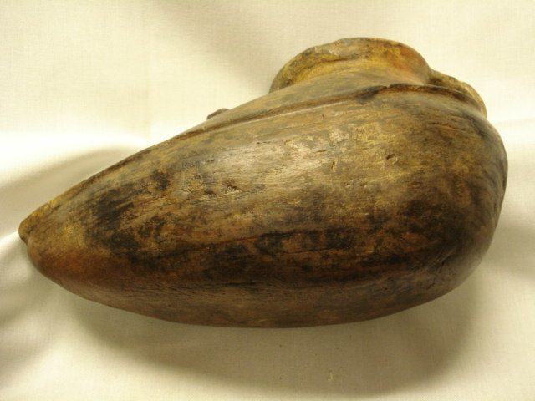

Figs. 1-4. **Guatemala-**Lake Amatitlan-Foot-shaped Ceramic-Highland Mayan-Late Classic Period-550-900 CE

**Case no.: 9**

**Accession Number:**

**Formal Label: Guatemala-**Lake Amatitlan-Foot-shaped Ceramic-Highland Mayan-Late Classic Period-550-900 CE

**Display Description:** This pothad been deposited in Lake Amatitlan by the Highland Mayans for ceremonial purposes during the Late Classic Period. The Lake acted like a cenote for them and their ritual observance required the offering of gifts to the ancestors. These pointed, asymmetrical 'shoe-shaped' or “foot-shaped jars,” usually have one handle, and many have applied strips of clay in simple geometric shapes as in this example of an anthropomorphic face.

**LC Classification:**

**Date or Time Horizon:** 550-900 CE,

**Geographical Area:** obtained from Lake Amatitlan by divers.

**Map, GPS coordinates:** 14.49135 -90.59153; 14º29'28.87" N 90º35'29.52" W.

**Cultural Affiliation:** the Highland Mayan Late Classic Period

**Medium:** fired clay

**Dimensions:** H 6.5 in

**Weight:**

**Condition: original,** museum quality and has been evaluated by a professional. There is one 1 inch place on the rim were it was repaired, but this was done well and is the same color. There are also two tiny chips on the protruding rim surrounding the face. There are no missing pieces or gaps.

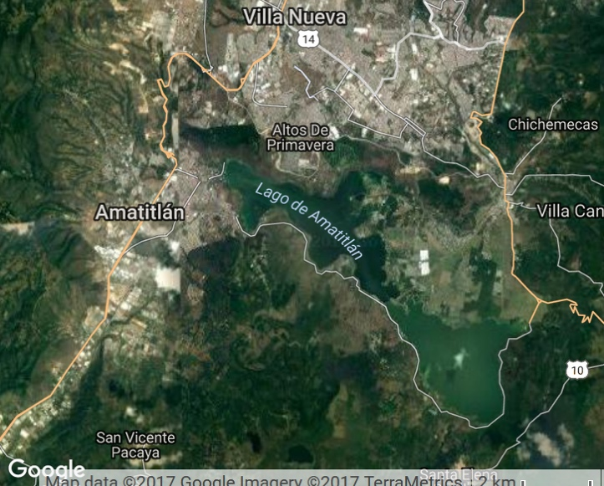

Fig. 5. Map showing location of Lago de Amatitlán and the peninsula of Altos de Primavera from whichit is believed the ceramic was found off-shore. From Google.

**Provenance:** obtained from Lake Amatitlan by divers. Then purchased in Guatemala City, Guatemala for an Illinois Estate, ca 1950.

**Discussion:** Bowl has notches, circles, and raised ridges made from outside by a stick and the potter's fingers. The bowl is meant to be a human face and has applied eyes, nose and mouth. This vessel has a handle at the back. This type of pot is extremely rare. I have only seen two or three in person or in pictures or in museums. Painted brown. No repainting. Color is bright, vivid. There are also parts of the pot where one can see it had lain on its side in the water and became more darkly colored because of contact with the silt or mud.

A specimen from the Institute of Anthropology and History, Ministry of Culture and Sports of Guatemala shows the result of being subject to soil salts for a long period in the ground:

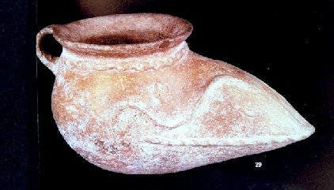

**Guatemala**-Foot-shaped Ceramic-Highland Mayan-Late Classic Period-550-900 CE. From the Institute of Anthropology and History, Ministry of Culture and Sports, http://dosfan.lib.uic.edu/usia/E-USIA/education/culprop/guatemal/ti/0000005c.jpg

**References:**

**AP: .2**